**SR UNIVRSITY**

**AI ASSISTED CODING   
ASSIGNMENT 10.2**

**NAME:** MOHAMMED MUTAKABIR HUSSAIN

**H.no**: 2503A51L35

**Task 1:**

**Task Description#1**

**AI-Assisted Code Review (Basic Errors)**

* Write python program as shown below.

Use an AI assistant to review and suggest corrections

Given code :

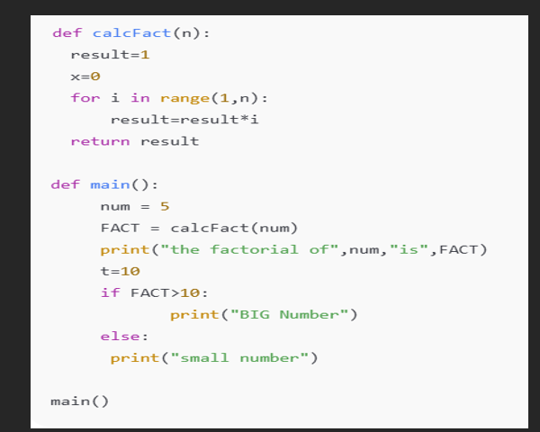

PROMPT :  
can you review and suggest corrections in the code also add comments in the code

**Code generated:**

Submitted corrected code with comments

**Output:**

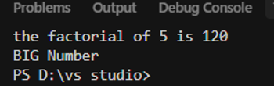

**Corrections and improvements made by AI**

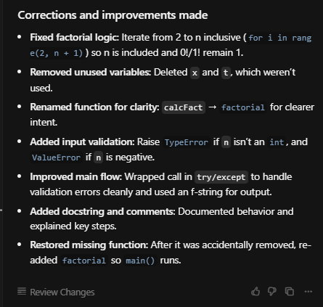

**Observation:**

I have observed that cursor ai has made some corrections in the given code and has added comments for better understanding and readability for the users

**TASK 2 :**

**Task Description#2 Automatic Inline Comments**

* Write the Python code for Fibonacci as shown below and execute.
* Ask AI to improve variable names, add comments, and apply PEP8 formatting (cleaned up).
* Students evaluate which suggestions improve readability most. one.

**Prompt:**

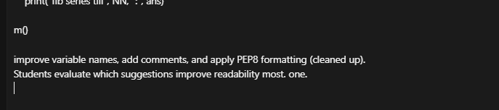

**Code generated:**

**Output:**  


**Observation:**

I have observed that the original code has no checks , no dogstrings and alos the input was 10 numbers but it was returning 11 numbers but in the ai generated code it corrected all these errors and impoved the code readability and also corrected the input and output numbers

**Task 3:**

**Task Description#3**

* Write a Python script with 3–4 functions (e.g., calculator: add, subtract, multiply, divide).
* Incorporate manual **docstring** in code with NumPy Style
* Use AI assistance to generate a module-level docstring + individual function docstrings.
* Compare the AI-generated docstring with your manually written one.

**Prompt:**

generate a module-level docstring + individual function docstrings using the code given to you

**Manually written code**

**AI generated code:**

**Output:**

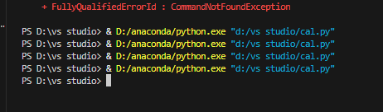

**Observation:**

Length of the manual written docstrings are focused on point and short in length,

Good for quick reading whereas the AI docstrings are longer are more detailed with extra info

Manual written code is easy to understand with just basic words but in the AI generated one

are a bit too much for simple functions .